**PETAL PALACE**

**Where blossoms bloom and flowers shine**

1)cityflowers.co.in

**Likes :**

* Flowers are recommended according to the occasion. (like birthday , anniversary , valentine's day etc). So we can choose our flowers without any confusion according to the occasion.

**Dislikes :**

* This website contains too much information because of which website looks a bit boring.
* Logo seems to be very basic it can be updated.

2)winni.in

**Likes :**

* The website is very easy to navigate making it user friendly.
* The use of navigation bar makes it convenient for the user to navigate throughout the website.

**Dislikes :**

* The template used is basic. Use of sliding bars , hover can make it more attractive.

3)floweraura.com

**Likes :**

* gift finder: This website provides us the option of gift finder where we need to just describe our need and they will recommend a gift according to our description.
* If we want to open a franchise we can login over here and request for the same.
* If we want to sell our products on the website we can use sell with us option and apply for the same.

**Dislikes :**

* This website contains too much information because of which website looks a bit boring.

4)proflowers.com

**Likes :**

* properks- provides various perks like Earn points on every purchase, Birthday surprise, Refer a friend rewards.

**Dislikes :**

* The colors used are not so appealing which makes the overall website look dull.

5)Interflora :

**Likes :**

* They have this facility of subscription flowers throught which they deliver flowers at our place every week.
* They have different options such as shortlist and cart making the website more user-friendly.
* They have also mentioned various celebrity customers to attract people and influence them.
* Special section of streaming videos adds to the beauty of the website.

**Dislikes :**

* no negative points.

**Mission :**

“PetalPalace aims to deliver fresh, captivating flowers to your doorstep, enhancing your special occasions with their fragrance and timeless beauty.”

**Criteria:**

1. **Responsiveness:** The website will be designed to be responsive and adaptable to different screen sizes and devices. This ensures that the site is accessible and visually appealing across various platforms.
2. **User-friendly :** The website should be easy to navigate, with intuitive menus, clear labels, and logical organization of content.
3. **Mobile-Optimization :** As the world is getting concise between mobile and tablets it is required to add few android friendly features.Hence increasing the reach of the website.
4. **Updates:** The information on the website should be current and up-to-date so every minute updations in the real world will be reflected here.
5. **Visual Appealing:** Aesthetically pleasing design, appropriate color schemes, high-quality images, and a visually engaging layout can enhance user experience.
6. **Content Quality:** The website should provide valuable and relevant content to its target audience. It should be well-written, accurate, up-to-date, and easy to understand. Add photographs and videos to enrich the content.
7. **Search Engine Optimization (SEO):** Implementing SEO best practices can help improve the website's visibility in search engine results.
8. **Relevancy:** The website should be relevant to the user's needs and interests. So, there will be no data redundancy.
9. **Security:** Website security is crucial to protect user data and maintain trust. Implementing SSL certificates, using secure connections (HTTPS), regularly updating software, and employing measures to prevent hacking or data breaches are important aspects of website security.
10. **Coverage:** The website should provide comprehensive coverage of the topic or subject matter.Hence, no topic is missed and will add to the completeness of the report.

**Success Criterion :**

1. **No. of Employees:** Once the website is deployed successfully the total no of employees required for any task will be reduced by 50%.
2. **Profit Rate:** After the deployment of the website the profit rate is predicted to increase by 15-20%.
3. **Improved Brand Awareness:** The website can contribute to increasing brand awareness and recognition. Success can be measured by monitoring metrics like social media mentions, brand searches, or direct traffic to the website. After the deployment of the website, it is predicted that the brand is expected to reach out to 36% more audience than before.
4. **Increased Sales :** Due to 24 x 7 availability sales has increased by nearly 27%.Increased Sales has helped the company to gain more profit.
5. **Improved Customer Satisfaction:** The website will provide a positive user experience and meet customer expectations. Collecting feedback through surveys or monitoring customer support inquiries can help measure customer satisfaction. The customer satisfaction level has increased by 30%.

**Visual Appeal :**

1. **Design Consistency:** A consistent design across different pages of a website creates a cohesive and professional look. This includes consistent color schemes, typography, and layout throughout the site.

The same design would be consistent throughout the website.

1. **Color Scheme:** Choosing an appropriate color palette that complements the website's purpose, brand identity, and target audience is essential. Colors will be visually pleasing, and harmonious, and convey the right emotions or messages. So,the Background color : ##ffe6ed to #fcfce6

Background color for images: #78C1F3

1. **User-Friendly Navigation:** Intuitive and user-friendly navigation is vital for a visually appealing website. Clear navigation menus, buttons, and links help users find the information they need quickly and easily, improving their overall experience.

As you can see in the image provided above there will be a navigation bar for the users to navigate throughout the website consisting of the following options :HOME , PRODUCTS , ABOUT, CART, LOGIN.

1. **Responsive Design:** Ensuring that the website is responsive and adapts well to different screen sizes and devices.
2. **Visual Hierarchy:** Creating a clear visual hierarchy will help guide users' attention and emphasizes important content. Proper use of headings, subheadings, bullet points, and other formatting techniques will make the content more scannable and visually appealing.
3. **Imagery and Media:** High-quality images, videos, icons, and other visual media elements can significantly enhance the visual appeal of a website. Using relevant and engaging visual content will attract attention, convey messages, and make the website more visually appealing.
4. **Typography:** Selecting suitable fonts and typography styles is important for readability and aesthetics. Fonts will be easy to read and consistent across different devices.

Font Size(Headings): 26 Color: Black Family: Geogria

Font Size(Text): 20 Color: Black Family: Cambria

**HOME PAGE :**

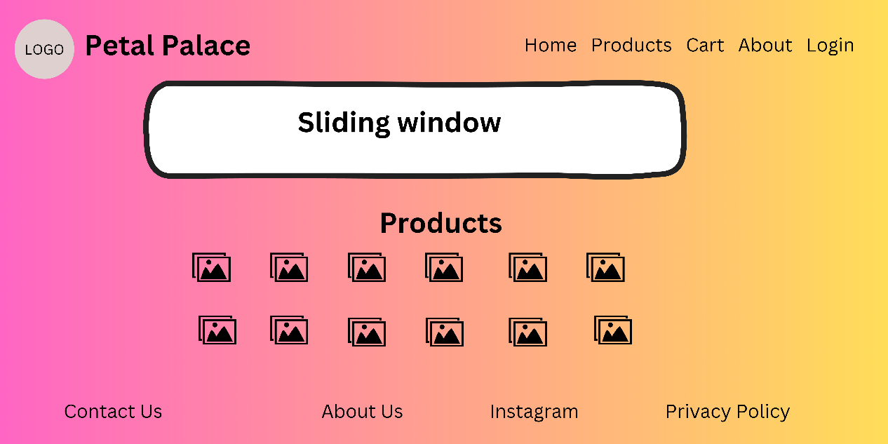

Footer Header

**LOGIN PAGE:**

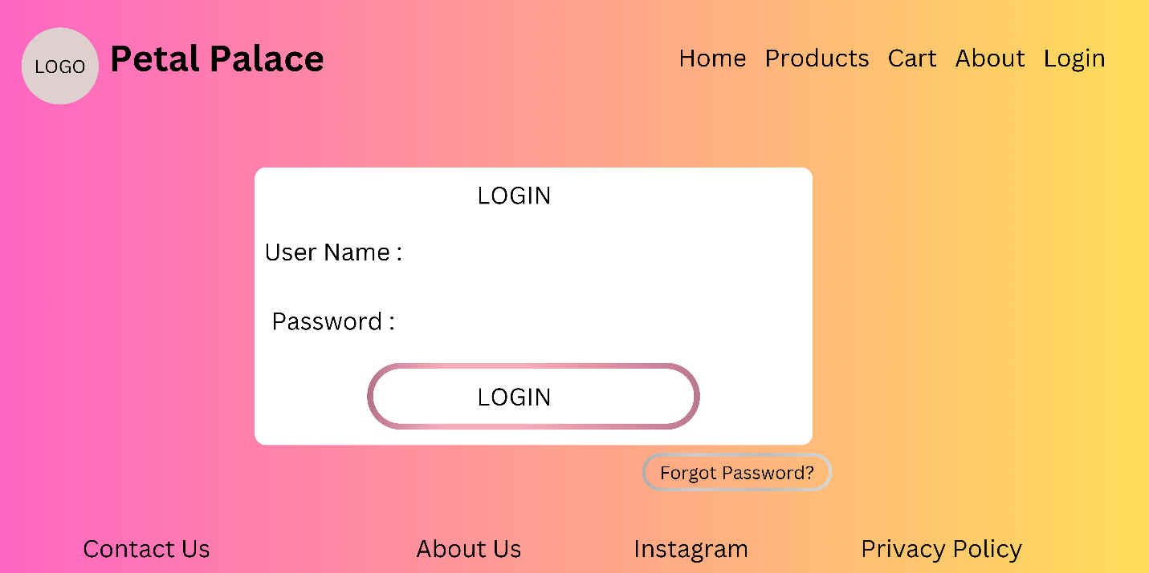

**PRODUCTS PAGE:**

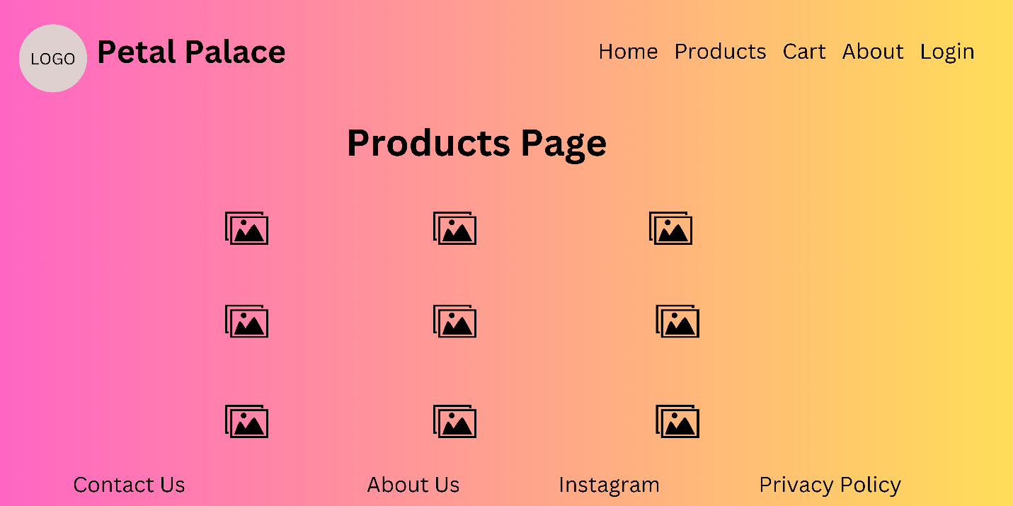

**CART PAGE:**

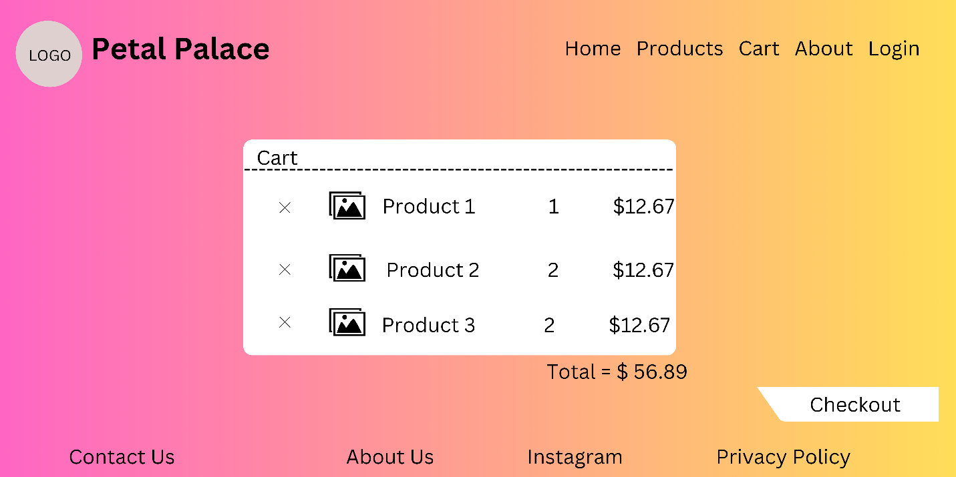

**ABOUT US PAGE:**

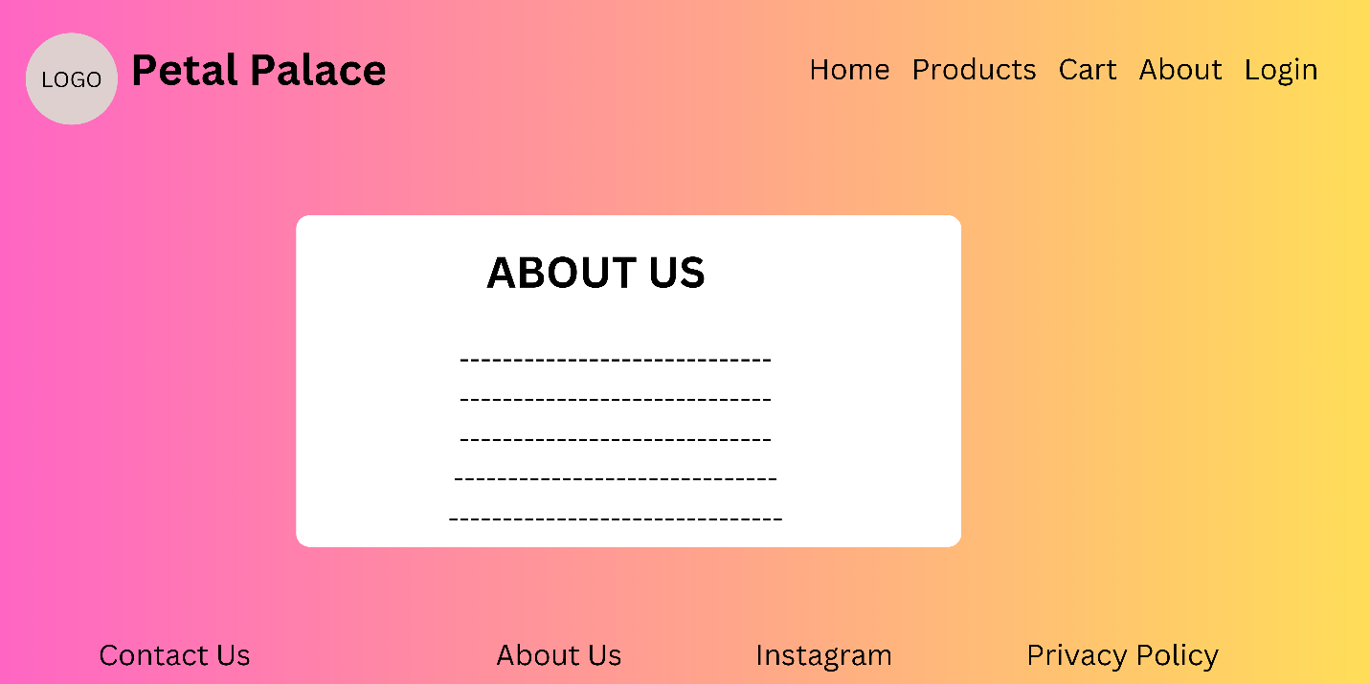

**CHECKOUT PAGE:**

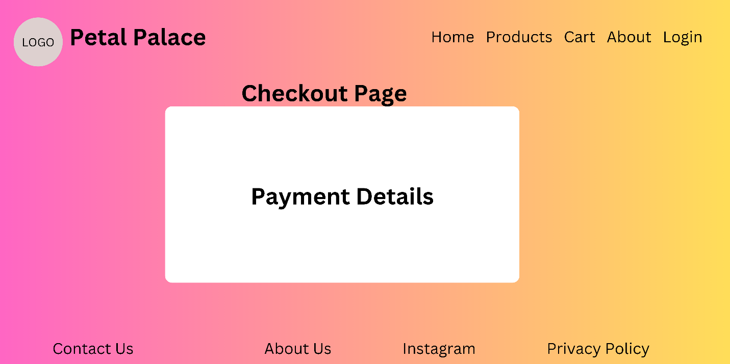

**CONTACT US PAGE:**

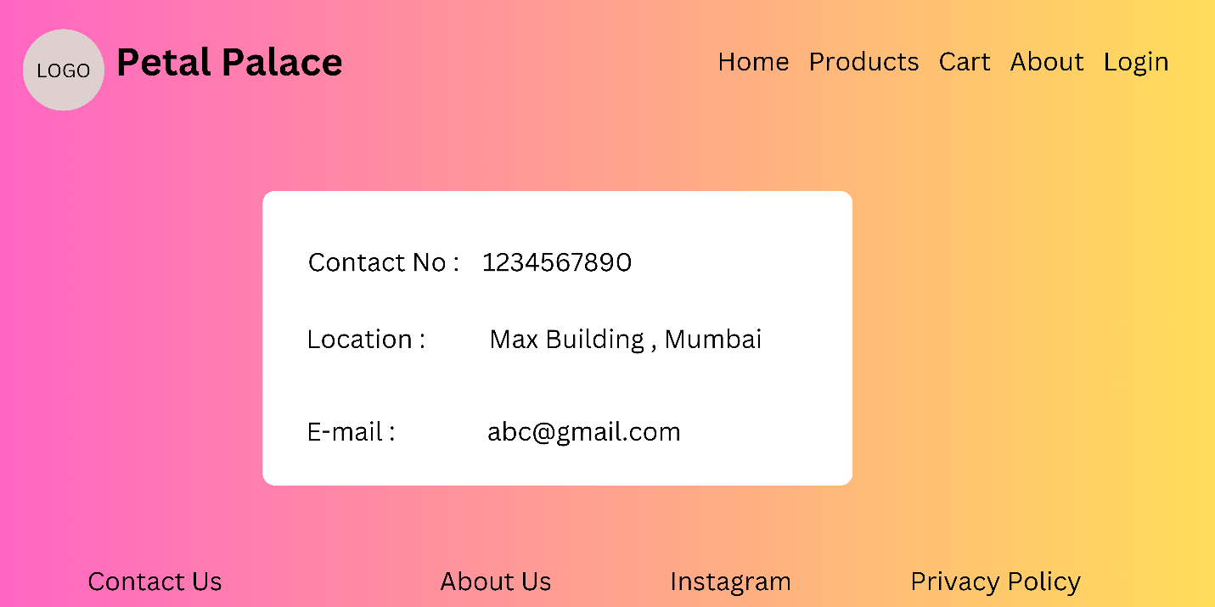

~ Aniket Jaiswal

Sanika Ingle

Rohit Patil